Handling submissions
Two forms let people outside the team put entries forward: Share your work (CBEDSense) and the Alliance Charter (CBEDSynergy).
Nothing they send reaches the site on its own. It only gets published if you copy it into draft/CBEDSync.xlsx yourself.
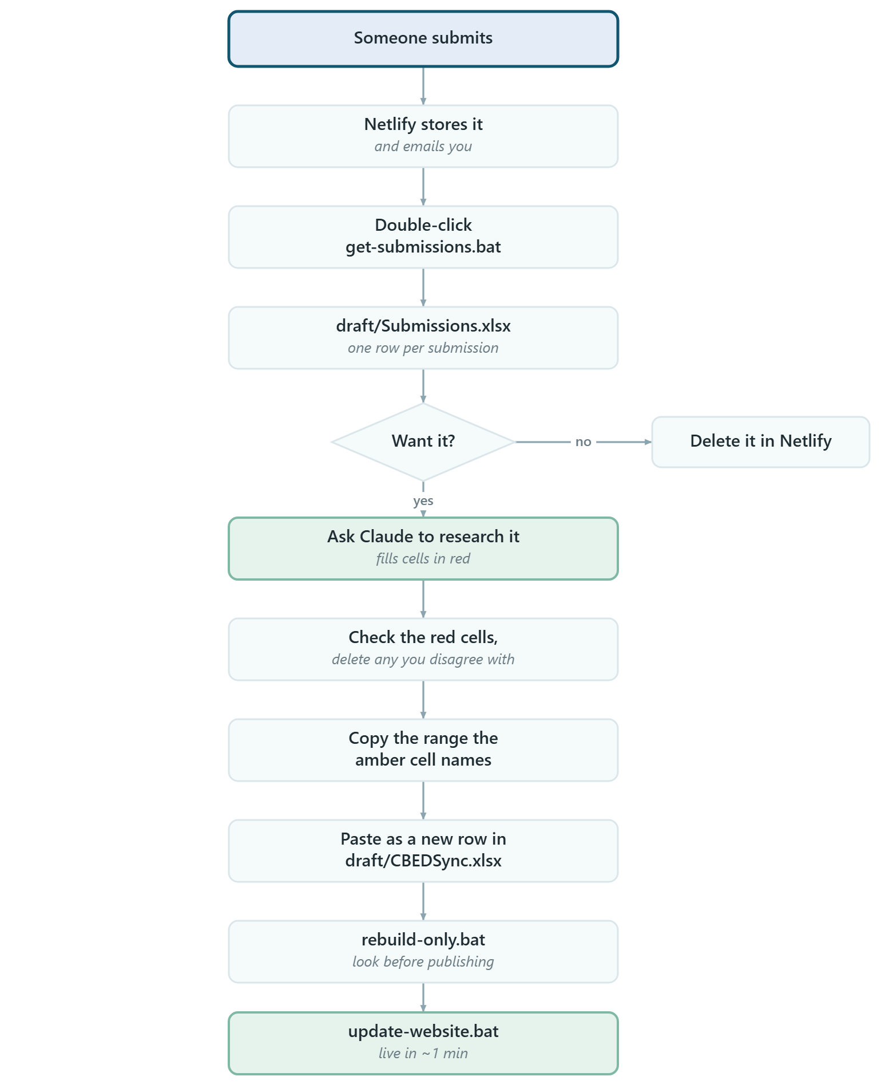

Setup (once)
At https://app.netlify.com/projects/cbeds/forms
- Turn form detection on. Two forms appear: cbeds-charter, cbedsense-submission.
- Add an email notification for each - before testing, or you get no email.
- Make a token at https://app.netlify.com/user/applications, then paste it into .env as NETLIFY_TOKEN=... (git-ignored; if Notepad saves .env.txt, set Save as type: All Files).

Reading the staging file
Columns A onwards | The master's own columns. Source already says Public.
Amber cell, row 1 | Says exactly what to copy, e.g. <- copy A:BM only. Read it, don't remember it - it moves if the master gains or loses a column.
Green Review: columns | Your notes. Never copied across.
Red text | A researched suggestion, not what the submitter wrote. Check before approving.

The research step
Ask Claude, pasting what the run printed. It reads a copy of CBEDSync.xlsx, searches online, and fills in type, dates, location, themes and links - all in red.
Two rules it follows: links only ever point at entities already in the graph (an invented name makes a dead link, not an error), and every suggestion is explained in Review: Notes. It never overwrites anything the submitter typed.

Watch out
- Never insert a column mid-sheet in Agent / Project / Output. The build reads by position - it will publish a wrong graph without complaining. New columns go at the far right.
- `Source` can't be reconstructed later. It comes across as Public already; don't clear it.
- A Charter signature is two things. The organisation becomes an Agent row; the named lead, date and commitments have no home there - keep those with your signatory record.
- draft/Submissions.xlsx holds names and emails and is kept out of GitHub.
- Free Netlify allows ~100 submissions/month (Billing > Usage).

If it complains
No NETLIFY_TOKEN found | Step 3 skipped, or Notepad saved .env.txt
Netlify refused the token | Token wrong or revoked - make a new one
Could not find a Netlify project... | It lists what your token can see; set NETLIFY_SITE
No CBEDS forms on cbeds | Detection off, or no deploy has carried the forms
...does not match the master's columns | Delete draft/Submissions.xlsx, run again (copy out any Review: notes first)
no "Source" column on ... | Add Source at the far right of that sheet
names shared by more than one entry | Not an error - two entries share a name, usually a company and its product
Python was not found | See HOW-TO-HOST-AND-UPDATE.md

Files
get-submissions.bat | collect
rebuild-only.bat | rebuild and stop
update-website.bat | publish
draft/CBEDSync.xlsx | the master
draft/Submissions.xlsx | the waiting room (generated, safe to delete)
.env | your token

Hosting and the Excel itself: HOW-TO-HOST-AND-UPDATE.md.
Generated from SUBMISSIONS.md. Edit the Markdown, not this file - the diagrams here are pictures and will go stale on their own.

